Little spotted kiwi survey Motuihe Island 26-29 March 2012
Rogan Colbourne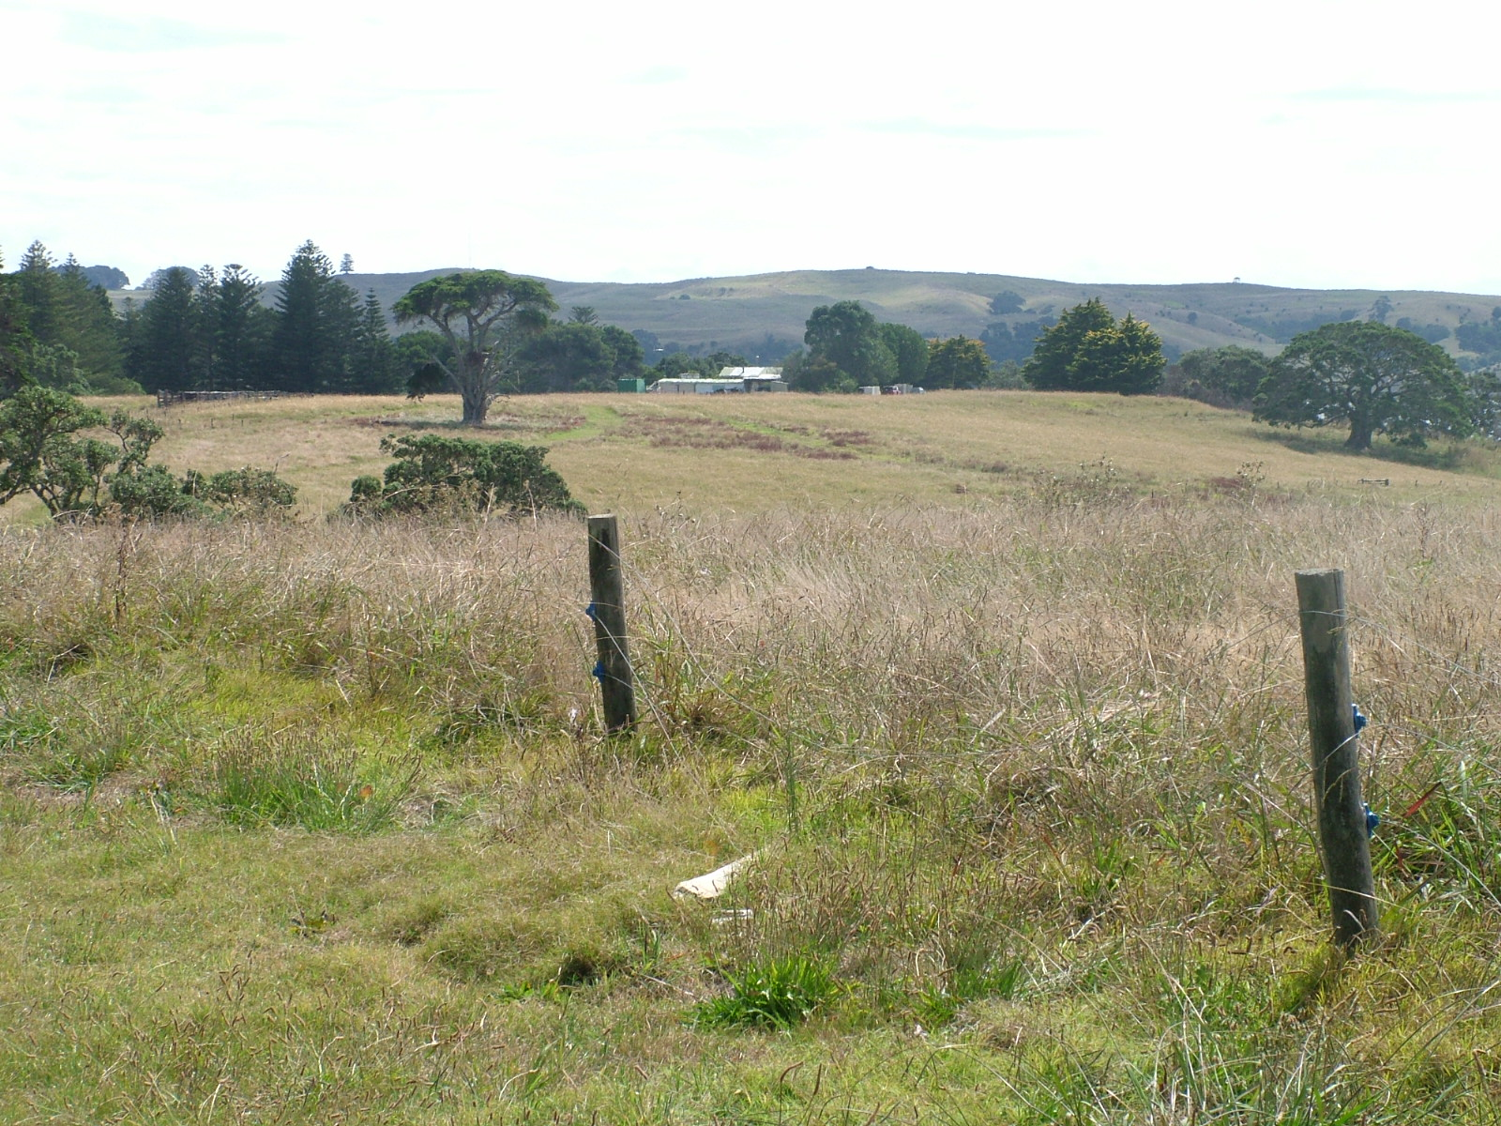
Retired farmland replanted with natives, Motuihe 2008
A total of 40 little spotted kiwi were translocated to Motuihe Island in two stages in 2009 and 2010. The 179 ha island in the Hauraki Gulf is predator free and the Motuihe Trust is planting the island in local native species. Immediately after the second release up to three kiwi were found dead on the beach, apparently drowned. A brief dog survey in 2010 found only two kiwi. It was with these concerns and uncertainties that a survey was planned for in March 2012.
Two nights were spent listening for kiwi calls using passive listening, playing recorded calls and using automated songmeter acoustic recorders. The party comprised of Rogan Colbourne, Dynett, Liz, and Betzy LLerena, Paul Gasson, Hazel Speedy and Steve Nelson, Three certified kiwi dogs, Jade, Abbie and Bracken were used to scent kiwi by day and Jade was used at night to pick-up scent.
Three males were caught at night.
26 March 12 GPS 2684045 6485308 O-31988 Red/white reflector bill 66.3 1050g medium to good condition
GPS 2683724 6485375 O-20469 white reflector bill 70.0 1150g good to medium condition
28 March 12 Orchard Bush Rotary lookout O-31987 red reflector bill 67.0 1170g good condition
Bracken found a kiwi by day in the base of a large Kohekohe at Von Luckner’s Bush GPS 2684201 6485475 but was too deep to extract.
There was quite a bias in number of males to females heard. In fact the party heard no females at the time and none responded to initiated calls! Yet, the Motuihe Trust had been using Bushnell trail cameras outside possible kiwi burrows and on at least four occasions females were seen entering and exiting in locations only males were heard. The Songmeters picked up three female calls.
There were a total of 13 male and three females detected. Given the brief survey some more could have been missed, and given females regularly call less often than males, it would be expected there would be a similar number to males. The night time dog tracking didn’t pick up scent at many more locations than those heard so it is likely there are in the order of 13-16 pairs established on the island. Some birds have failed to establish but the remaining birds are in good condition and an unbanded kiwi has been seen on the island from camera footage so there has been breeding.

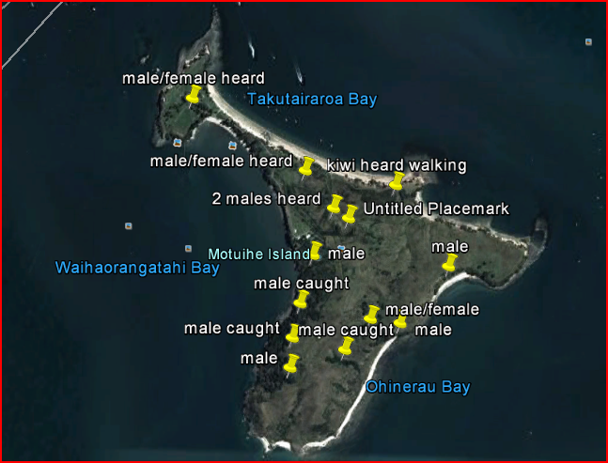Map showing locations of kiwi detected, Motuihe Island March 2012.
Kiwi were established in existing native bush patches and in replanted areas. None were detected in the open grasslands. One pair was recorded at the campground. It is possible the introduction did not do as well as that on Tiritiri Matangi because the plantings were at a younger stage when the kiwi were released and the rank grasses have a higher proportion of Paspalum grass. The seeds of this grass extrude a very sticky gum like substance that could severely mat a kiwi’s feathers and it is possible this habitat would have been avoided. Fortunately, with the resulting further native tree plantings, this grass weed will be suppressed in the future and more territory space will be opened up to little spotted kiwi. It is probable the drownings were caused by recently released kiwi not knowing the terrain of the island and having run over the steep cliffs. This has occasionally happened at releases of other kiwi species, but it is something the surviving kiwi do learn and the incidence lessens greatly with time.
The birds are healthy, cameras show they are in pairs and breeding has taken place. The habitat is improving all the time for kiwi. I believe the numbers are at their lowest point and will now continue to increase. Because the founding population suffered some casualties I would recommend in another four years, when the most recent plantings are a little bit more mature, to introduce another five to seven pairs of little spotted kiwi to add more genetic material. Perhaps Tiritiri Matangi could be a good source, being close by.
I would also recommend continuing with trail cameras to identify females and possibly the purchase of one or two acoustic recorders to listen for females and at set sites to monitor any increase in the call rate over time.

