**Motuihe Island Little Spotted Kiwi survey,**

**10-14 April 2017**

*Natasha Coad (Breeze, Bella), James Fraser (Peg, Duke)*

*With a Nose for Conservation*

**Background**

A total of 40 Little Spotted kiwi (LSK) were transferred from Kapiti Island to Motuihe Island in 2009 and 2010. Of these founder birds, three are known to have died and were found dead shortly after the second release.

Monitoring of birds has been undertaken by informal call-counts, trail camera observations and a survey was undertaken by Rogan Colbourne in March 2012. That survey identified the presence of 13 males and three females, thought to equate to 13-16 pairs. The three males caught at night in the 2012 survey were all in mod-good, to good condition.

Motuihe Island is 179ha of predominantly regenerated plantings with 18ha of remnant coastal forest. It has been pest free since 2005.

**Objective**

To conduct a survey to assess the LSK population density and condition of individual birds on Motuihe Island.

**Methods**

This survey was carried out using day time dog searching and night time call playback catching, also with the projection of calls of birds heard and not caught.

Kiwi were searched for during the day using two dog handler teams each with a Department of Conservation fully certified experienced threatened species dog (Breeze, Peg). Day work was also undertaken to assess the areas for night catching.

The focus was more on night work than day time survey work as the islands thick regenerating vegetation made it hard for dogs to locate birds without significant effort.

Night time search and catch work was undertaken as a single team. Kiwi calls were played via a MP3 player and an amplified speaker, or mouth whistled. Birds that came into the calls were run down and caught by hand or hand-net. Origin of kiwi calls heard at night were projected (direction and estimated distance) and waypointed using the hand-held GPS unit.

Once birds were caught, the bill was measured to 0.1mm, weight was measured to 10g. Body condition was assessed by feeling the ribs and backbone.

Adult birds were banded for future identification purposes.

All activities carried out in accordance with the draft Kiwi (*Apteryx* spp.) Best Practice Manual (2016).

**Results**

Three days and nights were spent surveying for kiwi.

A total of 16 birds was caught, seen or heard; representing approximately 12 pairs.

Six birds were caught at night (Table 1). Five were caught after they came into call playback, and one was a “random” encounter on a track in the grass that was run down when seen (R63687). All birds handled were in moderate to excellent condition.

One bird was located by the dogs during the day but could not be extracted from the big pohutukawa tree (also had a trailcam on the shelter-1774003 5924649). The bird could be identified as being an unbanded female. She was also present two days later when the site was re-checked.

Table 1: Information of birds caught



Three other males came into calls but eluded capture (campground area - above the wharf, volunteer house, Orchard Bush).

One male (O19823) caught on the first night was seen the second night 200m from the point of capture, identified by the reflective tape on his band.

Additionally, six individuals were identified from calls alone.

All birds caught or seen and projected calls are plotted on Map 1.

Map 1. Locations of birds caught, seen or heard on Motuihe Island. April 2017

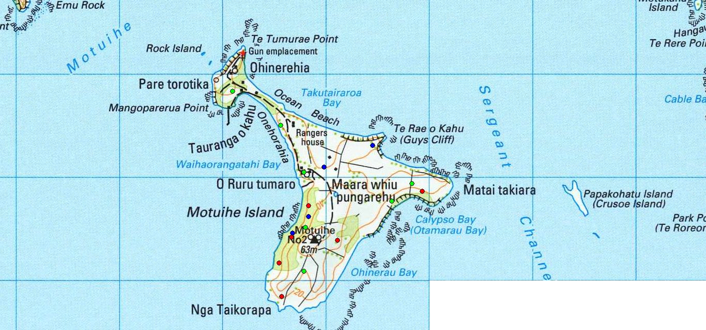

**O19823**

**O19841**

**O21324**

**R63687**

**O31975**

**O31974**

**UnK bird**

**Male call**

**UnB Male**

**Female call**

**Male call**

**Male call**

**Male call**

**Male**

**UnB female**

**Male call**

**Male call**

**Key:**

**• Bird caught**

**• Bird seen**

**• Bird heard**

**Discussion**

Approximately 12 pairs were identified from a combination of night-time catching, call origin projection and day-time dog survey. This is a very similar result to the survey conducted by Rogan Colbourne in 2012.

However the possible explanation for the lack of increase, gives a more positive outlook for the population than the result suggests.

The summer droughts experienced by the Auckland region in December 2015, and from December 2016 to January 2017 is known to have had a major effect on individual LSK on Tiritiri Matangi Island with birds being seen feeding during the day and at least two birds dying as a result. The recent five yearly survey on Tiritiri Matangi Island revealed that the population has declined since the previous survey, and there were some changes in territory ownership. We would expect that the drought effects would be similarly mirrored on Motuihe Island, and perhaps amplified as it is possible that Motuihe Island had a higher proportion of younger (and therefore more vulnerable ) birds than on Tiritiri Matangi Island.

The observed moderate (or better) body condition scores of birds handled on Motuihe Island demonstrates that birds are not being resource limited; and along with the detection of unbanded adults and a possible juvenile bird suggests that the population is increasing.

From the spacings of birds caught or encountered in the Orchard Bush and the range of the resighted reflected male, we have estimated that the territory sizes are around 7 hectares which is comparable to the 6.5 hectare territory size on Tiritiri Matangi Island. The growth of the population is dependent on the amount of habitat becoming available (through restoration) once the remnant bush areas have become fully occupied.

This survey (along with that on Tiritiri Matangi Island) was made more difficult by the unusually variable individual response to call playback and the lack of unsolicited vocalisation. Kiwi are thought to be less vocal and responsive during periods of full moon which occurred when we were on Motuihe (11/4/2017). It was noted by SoTM volunteers that during call count listening on 17/4/2017 there was significantly less calling than recorded the month before.

**Recommendations**

With the expectation that habitat restoration and enhancement will continue; and that as a result more of the island will become suitable kiwi habitat it would seem an opportune time to consider another release of Little Spotted kiwi to ensure the genetic robustness of the population.

While some hazards to kiwi can not be eliminated (cliffs), other hazards such as drain gratings and low sided water troughs should be identified and where possible removed or modified to remove the risk to kiwi.

From our extensive call count experience, we would recommend that call listenings are undertaken at the same time as those on Tiritiri Matangi Island and Shakespear Park. An attempt should also be made at the time of listening to identify the number of individual birds heard, and not just the total number of calls.