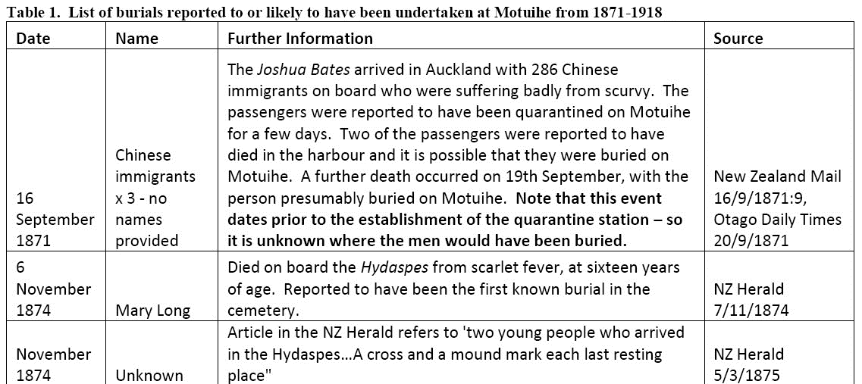
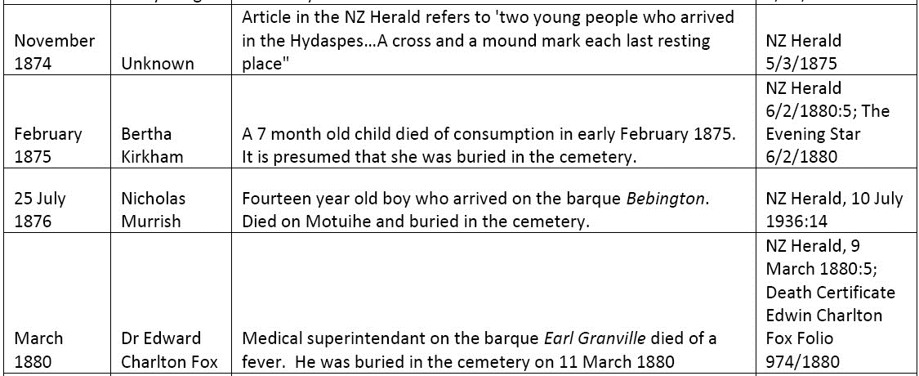
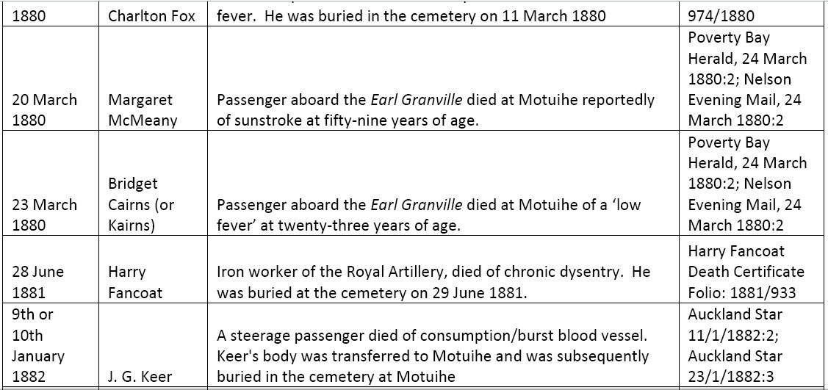
14 January 1882 | Patrick Finnicane (alias R T Crawford) | Labourer who died on Motuihe, possibly of small pox. Buried at the cemetery on 15th January | Auckland Star 17/1/1882 23/1/1882 Death certificate folio 17/1882

